Chapter X
Transactions
In Chapter X, we first touched on the middleware services needed for robust, secure, scalable, and reliable server-side development. This includes resource pooling services, security services, remotability services, persistence services, and more.
A key service that is required for robust server-side development is transactions. Transactions, when used properly, can make your mission-critical operations run predictably in an enterprise environment. Transactions are an advanced programming paradigm that allows you to write robust code. Transactions are also very useful constructs to use when performing persistent operations, such as updates to a database.
In the past, transactions have been difficult to use. Product developers needed to code directly to a transaction API. But with EJB, you can gain the benefits of transactions without performing any transaction programming.
In this chapter, we’ll see some of the problems that transactions solve. We’ll also see how transactions work and show how they’re used in EJB. Because transactions are at the very core of EJB and are somewhat difficult to understand, we’ll provide extensive background on the subject. To explain transactions properly, we’ll occasionally get a bit theoretical. If the theory presented in this chapter piques your interest, there are many tomes written on transactions available for further reading. See the book’s accompanying Web site, http://www.TheServerSide.com, for links to more information.
The Motivation for Transactions
We begin our discussion with a few motivational problems that transactions address.
Atomic Operations
Imagine that you’d like to perform multiple discrete operations, yet have them execute as one contiguous, large, atomic operation. Take the classic bank account example. When you transfer money from one bank account to another, you want to withdraw funds from one account and deposit those funds into the other account. Ideally, both operations will succeed. But if an error occurs, you’d like both operations to always fail--otherwise, you’ll have incorrect funds in one of the accounts. You never want one operation to succeed and the other to fail because both operations are part of a single atomic transaction.
One simplistic way to handle this is to perform exception handling. You could use exceptions to write a banking module to transfer funds from one account to another, as in the following pseudo-code:

try {
// Withdraw funds from account 1
}
catch (Exception e) {
// If an error occurred, do not proceed.
return;
}
try {
// Otherwise, deposit funds into account 2
}
catch (Exception e) {
// If an error occurred, do not proceed,
// and redeposit the funds back into account 1.
return;
}

This code tries to withdraw funds from account 1. If a problem occurs, then the application exits, and no permanent operations occur. Otherwise, we try to deposit the funds into account 2. If a problem occurs here, we redeposit the money back into account 1 and exit the application.
There are many problems with this approach:
- The code is bulky and unwieldy.
- We need to consider every possible problem that occurs at every step of the way and code error-handling routines to consider how to roll back our changes.
- Error-handling gets out of control if we perform more complex processes than a simple withdrawal and a deposit. It is easy to imagine, for example, a 10-step process that updates several financial records. We’d need to code error-handling routines for each step. In the case of a problem, we need to code facilities to undo each operation. This gets very tricky and error-prone to write.
- Testing this code is yet another challenge. You’d have to simulate logical problems as well as failures at many different levels.
Ideally, we would like a way to perform both operations in a single, large, atomic operation, with a guarantee that either both operations will either always succeed or both will always fail.
Network or Machine Failure
Let’s extend our classic bank account example and assume our bank account logic is distributed across a multi-tier deployment. This may be necessary for security, scalability, and modularization reasons. In a multi-tier deployment, any client code that wants to use our bank account application must do so across the network via a remote method invocation. We show this in Figure X.X.
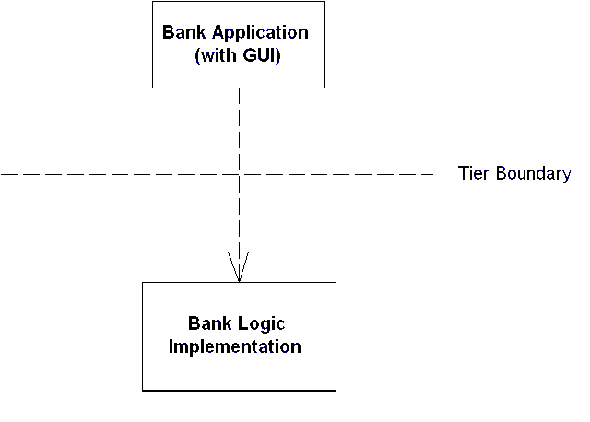
Figure X.X A distributed banking application.
Distributing our application across the network introduces failure and reliability concerns. For example, what happens if the network crashes during a banking operation? Typically, an exception will be generated and thrown back to the client code--but this exception is quite ambiguous in nature. The network may have failed before money was withdrawn from an account. It’s also possible that the network failed after we withdrew the money. There’s no way to distinguish between these two cases--all the client code sees is a network failure exception. Thus, we can never know for sure how much money is in the bank account.
In fact, the network may not be the only source of problems. Because we’re dealing with bank account data, we’re dealing with persistent information residing in a database. It’s entirely feasible that the database itself could crash. The machine that the database is deployed on could also crash. If a crash occurs during a database write, the database could be in an inconsistent, corrupted state.
For a mission-critical enterprise application, none of these situations is acceptable. Mainframe systems and other highly available systems offer preventive measures to avoid system crashes. But in reality, nothing is perfect. Machines, processes, or networks will always fail. There needs to be a recovery process to handle these crashes.
Multiple Users Sharing Data
In any enterprise-level distributed system, you will see the familiar pattern of multiple clients connecting to multiple application servers, with those application servers maintaining some persistent data in a database. Let’s assume these application servers all share the same database, as in Figure X.X. Because each server is tied to the same database image, servers could potentially be modifying the same set of data records within that database.
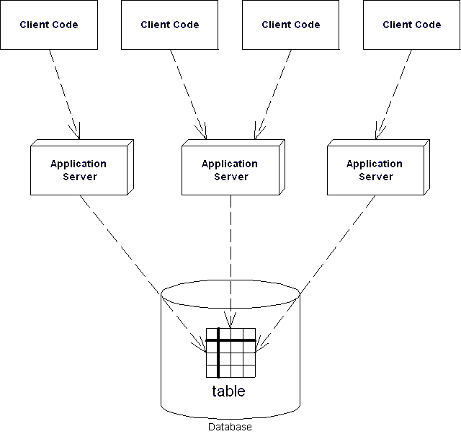
Figure X.X Application servers tied to a single database.
For example, you might have written a tool to maintain your company’s catalog of products in a database. Your catalog may contain product information that spans more than one database record. Information about a single product could span several database records or even tables.
It is conceivable that several people in your organization may need to use your tool simultaneously. But if two users modify the same product data simultaneously, their operations may become interleaved. Therefore, it is entirely possible that your database may contain product data that’s been partially supplied by one tool and partially supplied by another tool. This is essentially corrupted data, and it is not acceptable in any serious deployment. The wrong data in a bank account could result in millions of dollars in loss to a bank or the bank’s customers.
Thus, there needs to be a mechanism to deal with multiple users concurrently modifying data. We must guarantee that the many users concurrently updating data will not corrupt the data.
The Benefits of Transactions
The problems raised in the previous sections can lead to catastrophic errors. You can avoid these problems by properly using transactions.
A transaction is a series of operations that appear to execute as one large, atomic operation. Transactions guarantee an all-or-nothing value proposition: Either all of your operations will succeed, or none of them will. Transactions account for network or machine failure in a graceful, reliable way. Transactions allow multiple users to share the same data, and they guarantee that any set of data they update will be completely and wholly written, with no interleaving of updates from other clients.
By using transactions properly, you can enforce that multiuser interactions with databases (or other storages) occur independently. For example, if two clients are both reading and writing from the same database, they will be mutually exclusive if transactions are properly used. The database system will automatically perform the necessary concurrency control (i.e., locking) on the database to keep client threads from affecting each other.
As you will find out, transactions offer far more than simply letting simultaneous users use the same persistent stores. By having your operations run within a transaction, you are effectively performing an advanced form of concurrency control and exception handling.
Transaction Vocabulary
Before we get into the specifics of transactions, let’s get some vocabulary down. There are several types of participants in a transaction: transactional objects, transaction managers, resources, and resource managers. Let’s take a look at each of these parties in more detail.
A transactional object (or transactional component) is an application component, such as a banking component, that is involved in a transaction. This could be an enterprise bean, a Microsoft.NET managed component, a CORBA component, and so on. These components perform operations that need to execute in a robust fashion, such as database interactions.
A transaction manager is responsible for managing the transactional operations of the transactional components. It manages the entire overhead of a transaction, running behind the scenes to coordinate things (similar to how a conductor coordinates a symphony).
A resource is a persistent storage from which you read or write. A resource could be a database, a message queue, or other storage.
A resource manager manages a resource. An example of a resource manager is a driver for a relational database, object database, message queue, or other store. Resource managers are responsible for managing all state that is permanent. The most popular interface for resource managers is the X/Open XA resource manager interface. Most database drivers support this interface. Because X/Open XA is the de facto standard for resource managers, a deployment with heterogeneous resource managers from different vendors can interoperate.
The ACID Properties
When you properly use transactions, your operations will always execute with a suite of four guarantees. These four guarantees are well-known as the ACID properties of transactions. The word ACID stands for Atomicity, Consistency, Isolation, and Durability. Here’s the breakdown of each property:
Atomicity guarantees that many operations are bundled together and appear as one contiguous unit of work. In our banking example, when you transfer money from one bank account to another, you want to add funds to one account and remove funds from the other account, and you want both operations to occur or neither to occur. Atomicity guarantees that operations performed within a transaction undergo an all-or-nothing paradigm--either all the database updates are performed, or nothing happens if an error occurs at any time. Many different parties can participate in a transaction, such as an enterprise bean, a CORBA object, a servlet, and a database driver. These transaction participants can force the transaction to result in “nothing” happening for any reason. This is similar to a voting scheme--each transaction participant votes on whether the transaction should be successful, and if any vote “no” the transaction fails. If a transaction fails, all the partial database updates are automatically undone. In this way, you can think of transactions as a robust way of performing error handling.
Consistency guarantees that a transaction will leave the system’s state to be consistent after a transaction completes. What is a consistent system state? A bank system state could be consistent if the rule “bank account balances must always be positive” is always followed. This is an example of an invariant set of rules that define a consistent system state. During the course of a transaction, these rules may be violated, resulting in a temporarily inconsistent state. For example, your enterprise bean component may temporarily make your account balance negative during a withdrawal. When the transaction completes, the state is consistent once again. That is, your bean never leaves your account at a negative balance. And even though your state can be made inconsistent temporarily, this is not a problem. Remember that transactions execute atomically as one, contiguous unit of work (from the Atomicity property above). Thus, to a third party, it appears as though the system’s state is always consistent. Atomicity helps enforces that the system will always appear to be consistent.
Isolation protects concurrently executing transactions from seeing each other’s incomplete results. Isolation allows multiple transactions to read or write to a database without knowing about each other because each transaction is isolated from the others. Without isolation, your application state may become inconsistent. This is very useful for multiple clients modifying a database at once. To each client, it appears as though he or she is the only client modifying the database at that time. The transaction system achieves Isolation by using low-level synchronization protocols on the underlying database data. This synchronization isolates the work of one transaction from another. During a transaction, locks on data are automatically assigned as necessary. If one transaction holds a lock on data, the lock prevents other concurrent transactions from interacting with that data until the lock is released. For example, if you write bank account data to a database, the transaction may obtain locks on the bank account record or table. The locks guarantee that, while the transaction is occurring, no other concurrent updates can interfere. This allows many users to modify the same set of database records simultaneously without concern for interleaving of database operations.
Durability guarantees that updates to managed resources, such as database records, survive failures. Some examples of failures are machines crashing, networks crashing, hard disks crashing, or power failures. Recoverable resources keep a transactional log for exactly this purpose. If the resource crashes, the permanent data can be reconstructed by reapplying the steps in the log.
Transactional Models
Now that you’ve seen the transaction value proposition, let’s dive a bit deeper and explore how transactions work. We begin by taking a look at transactional models, which are the different ways you can perform transactions.
There are many different models for performing transactions. Each model adds its own complexity and features to your transactions. The two most popular models are flat transactions and nested transactions. We’ll see what each of these models is in the following sections.
Note
To use a particular transaction model, your underlying transaction service must support it. And unfortunately, not all of the vendors who crafted the EJB specification currently implement nested transactions in their products. Hence, Enterprise JavaBeans mandates flat transactions but does not support nested transactions. Note that this may change in the future based on industry demands.
Flat Transactions
A flat transaction is the simplest transactional model to understand. A flat transaction is a series of operations that are performed atomically as a single unit of work. After a flat transaction begins, your application can perform any number of operations. Some of those operations may be persistent operations, and some may not. When you decide to end the transaction, there is always a binary result: either success or failure. A successful transaction is committed, while a failed transaction is aborted. When a transaction is committed, all of the persistent operations become permanent changes--that is, all of the updates to resources, such as databases, are made durable into permanent storage only if the transaction ends with a commit. If the transaction is aborted, none of the resource updates are made durable, and thus all changes are rolled back. When a transaction aborts, all persistent operations that your application may have performed are automatically undone by the underlying system. Your application can also be notified in case of an abort, so that your application can undo in-memory changes that occurred during the transaction.
This is the “all-or-nothing” proposition we described above. All-or-nothing means that you can withdraw from one bank account and deposit into another bank account, armed with the knowledge that these operations will either both succeed (commit) or both fail (roll back). The flat transaction process is outlined in Figure X.X.
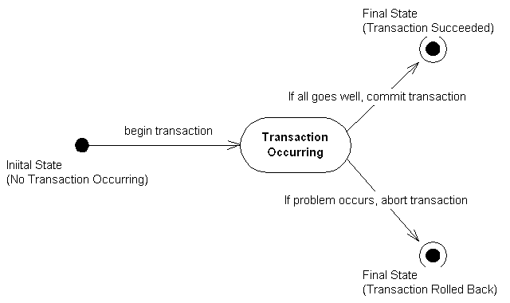
Figure X.X The flat transaction.
There are many reasons why a transaction might abort. As we’ve said, many components can be involved in a transaction, and any one component could suffer a problem that would cause an abortion. These problems include the following:
Invalid parameters passed to one of the components. For instance, a banking component may be called with a null argument, when it was expecting a bank account ID string.
An invariant system state was violated. For example, if a bank account has a negative balance, your banking component can force the transaction to abort, undoing all associated bank account operations.
Hardware or software failure. If the database that your component is using crashes, the transaction is rolled back, and all permanent changes are undone. Similarly, if there is a software failure (such as a distributed system where a JVM crashes) the transaction is rolled back as well.
Any of these problems can cause a transaction to abort. But when an abort occurs, how is the transactional state rolled back? That is the topic of the next section.
How Transactional State Is Rolled Back
Let’s assume you’re performing a flat transaction that includes operations on physical, permanent resources, such as databases. After the transaction begins, one of your business components requests a connection to a database. This database connection is automatically enlisted in the transaction in which your component is involved. Next, your component performs some persistent operations, such as database updates. But when this happens, your database’s resource manager does not permanently apply the updates to the database--that is, your persistent operations are not yet durable and permanent. Rather, the resource manager waits until a commit statement has been issued. A commit is issued only when all your business components have finished performing all of the operations under that transaction--that is, a commit is issued only when the transaction is complete. If the resource is told to commit, it persists the data permanently. If the transaction aborts, the data is not persisted at all.
The take-away point from this discussion is that your business components typically do not perform any rollback of permanent state; if there’s an abort, the resource (such as a database) does not make your database updates permanent. Your components don’t have any “undo” logic for permanent data inside of them--rather, the underlying system does it for you behind the scenes. Your components control the transaction and tell the transaction to abort, but the persistent state rollback is performed for you automatically. Thus, when your business components perform operations under a transaction, each of your components should perform all persistent operations assuming that the transaction will complete properly.
Now that you’ve seen flat transactions, let’s take a quick look at nested transactions.
Nested Transactions
We begin our nested transactions discussion with a motivational example. Let’s say you need to write an application that can plan trips for a travel agency. You need to code your application to plan trips around the world, and your application must purchase the necessary travel tickets for the trip. Consider that your application performs the following operations:
- Your application purchases a train ticket from Boston, USA to New York, USA.
- Your application purchases a plane ticket from New York, USA to London, England.
- Your application purchases a balloon ride ticket from London, England to Paris, France.
- Your application finds out that there are no outgoing flights from France.
This is the famous trip-planning problem. If this sequence of bookings were performed under a flat transaction, your application would have only one option: to roll back the transaction. Thus, because there are no outgoing flights from France, your application has lost all of its bookings! But there may be a way to replace the balloon ride with another trip, allowing you to salvage the train ticket and plane ticket. Thus, a flat transaction is insufficient. The all-or-nothing proposition is shooting us in the foot, and we need a more robust transactional model.
A nested transaction solves this problem. A nested transaction allows you to embed atomic units of work within other units of work. The unit of work that is nested within another unit of work can roll back without forcing the entire transaction to roll back. Therefore, the larger unit can attempt to retry the embedded unit of work. If the embedded unit can be made to succeed, then the larger unit can succeed. If the embedded unit of work cannot be made to work, then it will ultimately force the entire unit to fail.
You can think of a nested transaction as a tree of transactions, all spawning off one root- or top-level transaction. The root transaction is the “main” transaction--for instance, in our trip-planning example, the root transaction is the overall process of booking tickets around the world. Every other transaction in the tree is called a subtransaction. The subtransactions can be flat or nested transactions. Figure X.X illustrates this concept.
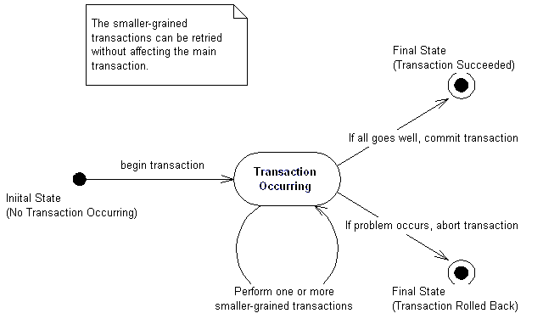
Figure X.X The nested transaction.
What’s special about nested transactions is that subtransactions can independently roll back, without affecting higher transactions in the tree. That’s a very powerful idea, and it solves our trip-planning problem: if each individual booking were a nested transaction, we could roll back any one booking without canceling all our other reservations. But in the end, if the nested transaction cannot be committed, the entire transaction will fail.
Other Transactional Models
This concludes our discussion of transactional models. There are other models as well, such as chained transactions and sagas, but we will not touch on these subjects here because the EJB specification does not support them. And because the EJB specification does not currently mandate support for nested transactions, we’ll assume that our transactions are flat for the rest of this chapter.
Enlisting in Transactions with Enterprise JavaBeans
Let’s apply what we’ve learned so far about transactions to the EJB world. If you’ll recall, the EJB component is an enterprise bean. Enterprise beans expose the business logic methods that clients invoke to perform useful operations, such as depositing or withdrawing from a bank account.
Enterprise beans can be transactional in nature. This means enterprise beans can fully leverage the ACID properties to perform reliable, robust server-side operations. Thus, enterprise beans are ideal modules for performing mission-critical tasks.
Transaction Models Supported
Currently, Enterprise JavaBeans supports only one flavor of transactions--flat transactions. This may change in the future, if other transactional varieties, such as nested transactions, long-lived transactions, and chained transactions, become more popular with database vendors. Flat transactions are very simple to understand, are ubiquitous, and give us enough power to accomplish most business needs (EJB was built to address the needs of the business community).
Underlying Transaction System Abstraction
In EJB, your code never gets directly involved with the low-level transaction system. Your enterprise beans never interact with a transaction manager or a resource manager. You write your application logic at a much higher level, without regard for the specific underlying transaction system. The low-level transaction system is totally abstracted out by the EJB container, which runs behind the scenes. Your bean components are responsible for simply voting on whether a transaction should commit or abort. If things run smoothly, you should commit; otherwise, abort.
Declarative, Programmatic, and Client-Initiated Transactions
Throughout this chapter, we’ve said that once a transaction begins, it ends with either commit or abort. The key piece of information we’re lacking is who begins a transaction, and who issues either a commit or abort, and when each of these steps occurs. This is called demarcating transactional boundaries. As we will see, there are three ways to perform transactions: programmatically, declaratively, or client-initiated.
Programmatic Transactions
Most existing systems demarcate transactional boundaries programmatically. When using programmatic transactions, you are responsible for programming transaction logic into your application code. That is, you are responsible for issuing a begin statement and either a commit or an abort statement.
For example, an EJB banking application might have an enterprise bean that acts as a bank teller. A teller bean would expose a method to transfer funds from one bank account to another. With programmatic transactions, the teller bean is responsible for issuing a begin statement to start the transaction, performing the transfer of funds, and then issuing either a commit or abort statement. This is the traditional way to perform transactions, and it is shown in Figure X.X.
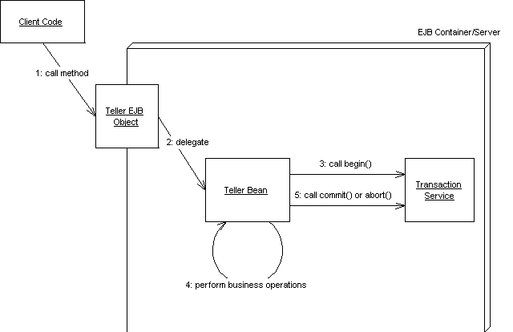
Figure X.X Beans with programmatic transactions.
Declarative Transactions
Declarative transactions allow for components to automatically be enlisted in transactions. That is, your enterprise beans never explicitly issue a begin, commit, or abort statement. Rather, the EJB container performs it for you.
Let’s take our bank teller example again, and assume some client code has called our teller bean to transfer funds from one account to another. With declarative transactions, the EJB container intercepts the request and starts up a transaction automatically on behalf of your bean. That is, the container issues the begin statement to the underlying transaction system to start the transaction. The container then delegates the invocation to your enterprise bean, which performs operations in the scope of that transaction. Your bean can do anything it wants to, such as perform logic, write to a database, send an asynchronous message, or call other enterprise beans. If a problem occurs, the bean can signal to the container that the transaction must abort. When the bean is done, it returns control back to the container. The container then issues either a commit or abort statement to the underlying transaction system, depending on whether a problem occurred. This is a very simple model, and it is shown in Figure X.X.
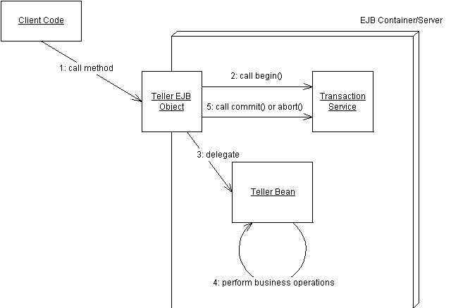
Figure X.X Beans with declarative transactions.
EJB declarative transactions add huge value to your deployments because your beans may not need to interact with any transaction API. In essence, your bean code and your client are not even really aware of transactions happening around them.
So how do you instruct the container about whether your bean is using declarative or programmatic transactions? EJB allows you to specify how your enterprise bean is enrolled in a transaction through the deployment descriptor, as follows:
<!DOCTYPE ejb-jar PUBLIC "-//Sun Microsystems, Inc.//DTD Enterprise JavaBeans 2.0//EN" "http://java.sun.com/dtd/ejb-jar_2_0.dtd">

<ejb-jar>
<enterprise-beans>
<session>
<ejb-name>Hello</ejb-name>
<home>examples.HelloHome</home>
<remote>examples.Hello</remote>
<ejb-class>examples.HelloBean</ejb-class>
<session-type>Stateless</session-type>
<transaction-type>Container</transaction-type>
</session>
</enterprise-beans>
</ejb-jar>
The above deployment descriptor chooses container-managed (declarative) transactions. If instead of Container we chose Bean, then we would use bean-managed (programmatic) transactions.
Transactions and Entity Beans
Perhaps one of the most misunderstood concepts in EJB is how transactions relate to entity beans. This sidebar explains how transactions and entity beans work together.
When you call an entity bean in a transaction, the first action that happens is the entity bean needs to load database data through the ejbLoad() method, which acquires locks in the database and ensures the entity bean cache is consistent. Then one or more business methods are called. When the transaction is committed, the entity bean's ejbStore() method is called, which writes all updates to the database and releases the locks. A transaction should thus span both ejbLoad(), business methods, and the final ejbStore(), so that if any one of those operations fail, they all fail.
If we were to use bean-managed transactions, then we would write code to perform begin() and commit() methods inside our bean (perhaps around the JDBC code). Perhaps we would start the transaction in ejbLoad(), and then commit the transaction in ejbStore(). The problem though is that you do not call your own ejbLoad() or ejbStore() methods--the container does. The bean cannot enforce that these methods happen in this order, if at all. Therefore, if you started a transaction in ejbLoad(), the transaction may never complete.
Thus, bean-managed transactions are illegal for entity beans. Entity beans must use declarative transactions. Session beans or message-driven beans can use bean-managed transactions because a session bean could load database data, perform operations on that data, and then store that data, all in a single method call, and thus is in direct control over the transaction.
A corollary of this discussion is that entity beans do not load and store their data on every method call, but rather they load and store their data on every transaction. If you are finding that your entity beans are not performing well, it could be because a transaction is happening on each method call, and thus a database read/write is happening on every get/set method. The solution is to make sure your transactions begin earlier and end later, perhaps encompassing many entity bean method calls. By properly controlling the duration of your transactions with transaction attributes (as we will see later in this chapter), you can control when database reads and writes happen with entity beans. For more on this design strategy, see Chapter X.
Client-Initiated Transactions
The final way to perform transactions is to write code to start and end the transaction from the client code outside of your bean. For example, if you have a servlet, JSP tag library, application, applet, CORBA client, or other enterprise bean as a client of your beans, you can begin and end the transaction in that client. This is shown in Figure X.X.
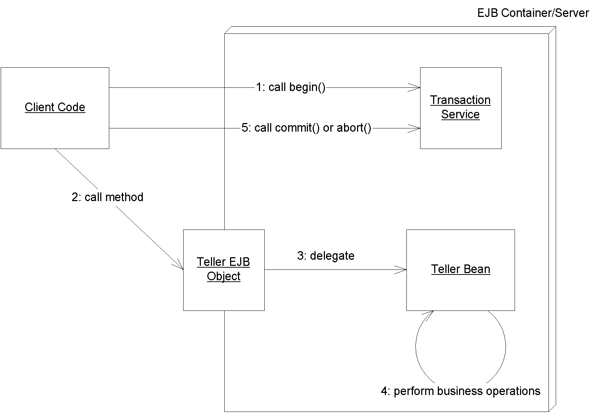
Figure X.X Beans with client-initiated transactions
Note that the enterprise bean that the client calls would still need to be written to use either programmatic or declarative transaction.
Choosing a transaction style
One question that students often ask in our EJB training classes is, "should I use declarative, programmatic, or client-controlled transactions?"
The benefit of programmatic transactions is that your bean has full control over transactional boundaries. For instance, you can use programmatic transactions to run a series of mini-transactions within a bean method. By way of comparison, with declarative or client-initiated transactions, your entire bean method must either run under a transaction or not run under a transaction.
The benefit of declarative transactions is that it is simpler. You don't need to write transactional logic into your bean class, which saves coding time and allows you to tune transactions without having access to source code. Also, by having transactions automatically start up and end, you keep client code from misusing your beans. If you’re a bean vendor, this will reduce a great number of headaches down the line.
To understand the benefit of client-controlled transactions, consider the following scenario where we don't use client-controlled transactions. Imagine that a non-transactional remote client calls an enterprise bean that performs its own transactions (either programmatically or declaratively). The bean succeeds in the transaction, but the network or application server crashes before the result is returned to a remote client. The remote client would receive a Java RMI RemoteException indicating that there was a network error. However, the remote client would not know whether the transaction that took place in the enterprise bean was a success or a failure, because all the remote client would perceive is a network error. The remote client would then have to write code to check the state of the server if a RemoteException was ever thrown, and this code can get very, very messy, and is error-prone because it may never be able to contact the server.
With client-controlled transactions, you do not need to worry about the above scenario, because the transaction is defined in the client code and thus if anything goes wrong, the client will know about it. The downside to client-controlled transactions is if the client is located far away from the server, then the transactions are likely to rollback due to conflicts. Because of this, if the client is far away then you should use client-transactions sparingly.
Container-Managed Transactions
Let's now assume that we are using container-managed transactions, and understand how to implement them. Although we're not writing any code that starts and stops transactions, we'll still need to provide instructions to the container for how we'd like our transactions to operate. For example, how can we choose whether a bean always runs in a transaction, or that a bean never runs in a transaction?
A transaction attribute is a setting that you give to a bean to control how your bean is enlisted in container-managed transactions. You can specify a different transaction attribute on each bean in your system, regardless of how many beans are working together.
The transactional attribute is a required part of each bean’s deployment descriptor. The container knows how transactions should be handled with a bean by reading that bean’s transaction attribute from its deployment descriptor. Note that you can specify transaction attributes for entire beans or for individual bean methods. If both are specified, then method-level attributes take precedence.
Source X.X demonstrates transaction attributes.
<assembly-descriptor>

<!--
This demonstrates setting a transaction attribute
on every method on the bean class.
-->
<container-transaction>

<method>
<ejb-name>Employee</ejb-name>
<method-name>*</method-name>
</method>

<!--
Transaction attribute. Can be "NotSupported",
"Supports", "Required", "RequiresNew",
"Mandatory", or "Never".
-->
<trans-attribute>Required</trans-attribute>

</container-transaction>

<!--
You can also set transaction attributes on individual methods.
-->
<container-transaction>

<method>
<ejb-name>Employee</ejb-name>
<method-name>setName</method-name>
</method>

<trans-attribute>Required</trans-attribute>

</container-transaction>

<!--
You can even set different transaction attributes on
methods with the same name that take different parameters.
-->
<container-transaction>

<method>
<ejb-name>Employee</ejb-name>
<method-name>setName</method-name>
<method-param>String</method-param>
</method>

<trans-attribute>Required</trans-attribute>

</container-transaction>

</assembly-descriptor>
Source X.X Declaring Transaction Attributes in the Deployment Descriptor.
You must specify transaction attributes on all business methods for your beans. Furthermore, with entity beans you must specify transaction attributes that cover home interface methods, because the home interface creation methods insert database data and thus need to be transactional.
EJB Transaction Attribute Values
Every enterprise bean must have a transaction attribute setting. The following are the possible values for the transaction attribute in the deployment descriptor.
A Recurring Theme
Declarative transactions allow you to delegate transactional logic to the application server. This allows you to construct server-side component-based applications without writing to middleware APIs. Indeed, this has been a recurring theme of this book, and it is the EJB value proposition. As a component developer, you’re responsible for setting properties on your components through the deployment descriptor, which inform the application server about the middleware services that you need. The middleware services you gain include persistence, security, transactions, transparent networking, and more. This empowers you to rapidly develop server-side applications from prewritten components, allowing you to easily flip property settings as necessary to tune components to your environment.
Required
You should use the Required mode if you want your bean to always run in a transaction. If there’s a transaction already running, your bean joins in on that transaction. If there is no transaction running, the EJB container starts one for you.
For instance, let’s say you write a credit card component that performs operations on credit cards, such as charging a credit card or refunding money on a credit card. Let’s assume you ship the component with the Required transaction attribute. You then sell that component to two customers:
Customer 1 deploys our component in its customer service center, using the component to refund money when an angry customer calls up. The customer writes some proprietary code to call your bean as necessary. When the client code calls your bean, the container will automatically start a transaction by calling begin and then delegating the call to your bean. When your method completes, the container will either issue a commit or abort statement, depending on whether a problem occurred.
Customer 2 uses our billing component as part of a complete workflow solution. The customer wants to use the credit card component to charge a user’s credit card when a user purchases a product from a Web site. The customer then wants to submit an order to manufacture that product, which is handled by a separate component. Thus, the customer has two separate components running, but he or she would like both of them to run under the same transaction. If the credit card cannot be charged, the customer doesn’t want the order to be submitted. If the order cannot be submitted, the customer doesn’t want the credit card charged. Therefore, the customer produces his or her own workflow bean, which first calls our credit card charging bean and then calls the bean to generate a manufacturing order. The workflow bean is deployed with Required, so a transaction automatically starts up. Because your credit card bean is also deployed with Required, you join that transaction, rather than starting your own transaction. If the order submission component is also deployed with Required, it will join the transaction as well. The container commits or aborts the transaction when the workflow bean is done.
Thus, Required is a very flexible transaction attribute, and it allows you to start your own transaction or join existing ones, depending on the scenario.
RequiresNew
You should use the RequiresNew attribute if you always want a new transaction to begin when your bean is called. If there is a transaction already underway when your bean is called, that transaction is suspended during the bean invocation. The container then launches a new transaction and delegates the call to the bean. The bean performs its operations and eventually completes. The container then commits or aborts the transaction and finally resumes the old transaction. Of course, if there is no transaction currently running when your bean is called, there is nothing to suspend or resume.
RequiresNew is useful if your bean needs the ACID properties of transactions but wants to run as a single unit of work without allowing other external logic to also run in the transaction.
Supports
When a bean is called with Supports, it runs only in a transaction if the client had one running already--it then joins that transaction. If the client does not have a transaction, the bean runs with no transaction at all.
Supports is similar in nature to Required, with the one exception that Required enforces that a new transaction is started if one is not running already. Because Supports will sometimes not run within a transaction, you should be careful when using this attribute. Mission-critical operations should be encapsulated with a stricter transaction attribute (such as Required).
Mandatory
Mandatory mandates that a transaction must be already running when your bean method is called. If a transaction isn’t already running, then the javax.ejb.TransactionRequiredException exception is thrown back to the caller (or javax.ejb.TranasctionRequiredLocalException exception if the client is local).
Mandatory is a safe transaction attribute to use. It guarantees that your bean should run in a transaction. There is no way your bean can be called if there isn’t a transaction already running. However, Mandatory relies on a third party to start the transaction before your bean is called. The container will not automatically start a transaction; rather, an exception is thrown back to the caller. This is the chief difference between Mandatory and Supports. Mandatory is useful if your component is designed to run within a larger system, such as a workflow system, where your bean is only part of a larger suite of operations, and you want to mandate that the larger operations start a transaction before calling your bean.
NotSupported
If you set your bean to use NotSupported, then your bean cannot be involved in a transaction at all. For example, assume we have two enterprise beans, A and B. Let’s assume bean A begins a transaction and then calls bean B. If bean B is using the NotSupported attribute, then the transaction that A started is suspended. None of B’s operations are transactional, such as reads/writes to databases. When B completes, A’s transaction is resumed.
You should use NotSupported if you know for sure that your bean operations do not need the ACID properties. This should be used only if your beans are performing nonmission-critical operations, where you are not worried about isolating your bean’s operations from other concurrent operations. An example here is an enterprise bean that performs rough reporting. If you have an e-commerce Web site, you might write a bean that routinely reports a rough average number of e-commerce purchases per hour by scanning a database. Because this is a low-priority operation and you don’t need exact figures, NotSupported is an ideal, low-overhead mode to use.
Never
The Never transaction attribute means that your bean cannot be involved in a transaction. Furthermore, if the client calls your bean in a transaction, then the container throws an exception back up to the client (java.rmi.RemoteException if remote, javax.ejb.EJBException if local).
This transaction attribute is useful when you want to make sure all clients that call your bean do not use transactions. This can help reduce errors in client code, because a client will not be able to erroneously call your bean in a transaction and think that your bean will participate in the ACID properties with other transaction participants. If you are developing a system that is not transactional in nature, and would like to enforce that behavior, then consider using the Never attribute.
Transaction Attribute Summary
Table X.X is a summary of the effects of each transaction attribute. In the chart, T1 and T2 are two different transactions. T1 is a transaction passed with the client request, and T2 is a secondary transaction initiated by the container.
@@@COMP: Note the merged cells in this table@@@
Transaction attribute | Client's transaction | Bean's Transaction
Required | none | T2
Required | T1 | T1
RequiresNew | none | T2
RequiresNew | T1 | T2
Supports | none | none
Supports | T1 | T1
Mandatory | none | error
Mandatory | T1 | T1
NotSupported | none | none
NotSupported | T1 | none
Never | none | none
Never | T1 | error
Table X.X The effects of transaction attributes
Table X.X is important because you can use this information to control the length of your transaction. For example, let's say you want to perform a bank account transfer between two bank accounts. To achieve this, you might have a bank teller session bean that calls into two bank account entity beans. If you deploy all three of these beans with the Required transaction attribute, then they will all be involved in a single transaction, as shown in Figure X.X.
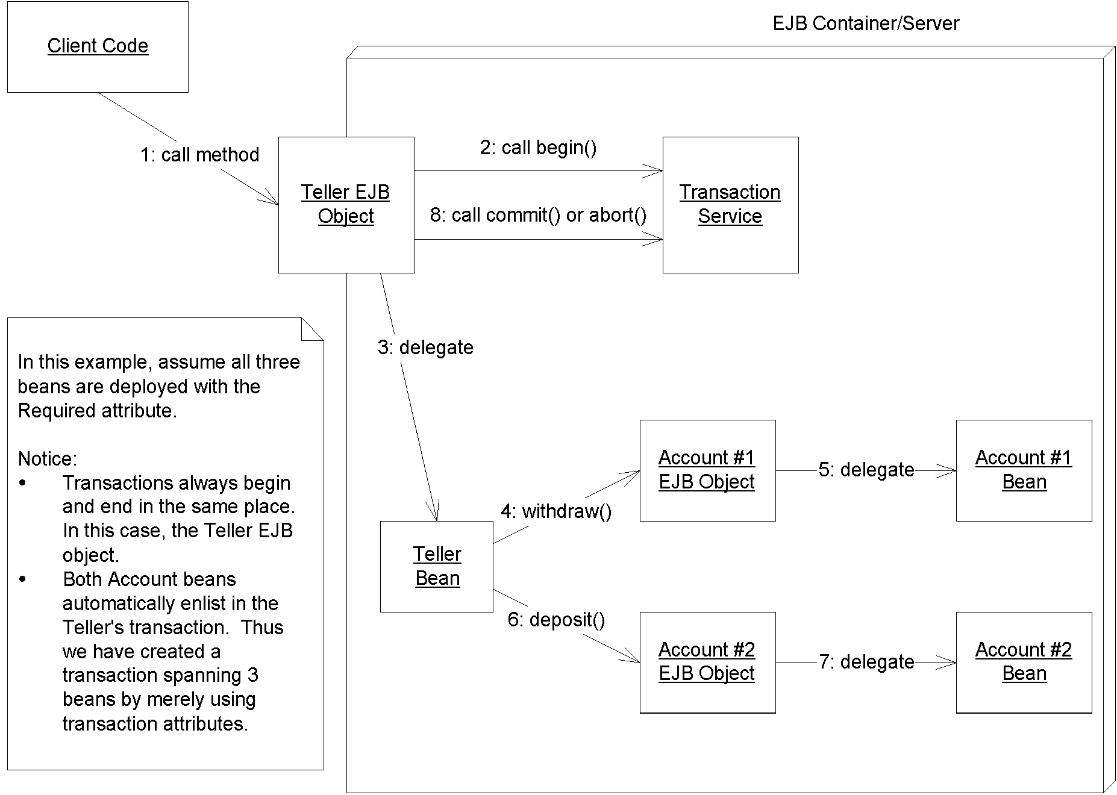
Figure X.X Using transaction attributes to control a transaction's length
Finally, you should note that not all transaction attributes are available for use on all beans. Table X.X shows which are permissible.
Transaction Attribute | Stateless Session Bean | Stateful Session Bean implementing SessionSynchronization | Entity Bean | Message-driven bean
Required | Yes | Yes | Yes | Yes
RequiresNew | Yes | Yes | Yes | No
Mandatory | Yes | Yes | Yes | No
Supports | Yes | No | No | No
NotSupported | Yes | No | No | Yes
Never | Yes | No | No | No
Table X.X Permissible transaction attributes for each bean type
Here is a brief explanation of why certain transaction attributes are disallowed.
- Entity beans and stateful session beans with SessionSynchronization must use transactions. The reason is because both these types of beans are inherently transactional in nature. Entity beans perform database updates, and stateful session beans with SessionSynchronization (which we describe later in this chapter) are also transactional. Therefore you can't use the following attributes: Never, NotSupported, Supports.
- A client does not call a message-driven bean directly--rather, message-driven beans read messages off a message queue in separate transactions than the client's transaction. There is no client, and therefore transaction attributes that deal with the notion of a client's transaction make no sense for message-driven beans--namely Never, Supports, RequiresNew, and Mandatory.
Programmatic Transactions in EJB
Next, let's discuss how you can control transactions programmatically in EJB. Programmatic transactions allow for more advanced transaction control than declarative transactions, but they are trickier to use. To control transaction boundaries yourself, you must use the Java Transaction API (JTA). We begin by taking a look at how the JTA was established.
CORBA’s Object Transaction Service (OTS)
When we described the ACID properties earlier in this chapter, we mentioned that many parties, such as an enterprise bean and a database driver, can participate in a transaction. This is really an extension to the basic ACID properties, and it’s the primary reason that Object Management Group (OMG) developed a standardized Object Transaction Service (OTS) as an optional CORBA service. OTS improved on earlier transaction systems that didn’t support multiple parties participating in a transaction.
OTS is a suite of well-defined interfaces that specify how transactions can run behind the scenes--interfaces that the transaction manager, the resource manager, and the transactional objects use to collaborate. OTS is decomposed into two parts: CosTransactions and CosTSPortability.
The CosTransactions interfaces are the basic interfaces that transactional objects/components, resources, resource managers, and transaction managers use to interoperate. These interfaces ensure that any combination of these parties is possible.
The CosTSPortability interface offers a portable way to perform transactions with many participants.
The inner workings of OTS are not relevant to the development of enterprise beans. As an EJB programmer, you should need to think only about writing your application, not about low-level transaction services. This is how EJB achieves rapid application development; you can write a distributed server-side application without understanding complex middleware APIs. EJB shields you from transaction services such as OTS.
The Java Transaction Service (JTS)
Sun realized that you, as an application developer, should not care about most of OTS. Only system-level vendors need to be concerned with the inner workings of OTS. Part of OTS is very applicable to you, however, because part of OTS allows you to demarcate transaction boundaries programmatically. Hence, Sun has split up OTS into two sub-APIs: the Java Transaction Service (JTS) and the Java Transaction API (JTA).
The Java Transaction Service (JTS) is a Java mapping of CORBA OTS for system-level vendors. JTS defines the interfaces used by transaction managers and resource managers behind the scenes. It is used to have various vendors’ products interoperate. It also defines various objects passed around and used by transaction managers and resource managers. As an application programmer, you should not care about most of OTS, and you should not care about JTS at all. What you should care about is the Java Transaction API (JTA), which allows you to programmatically control transaction boundaries.
The Java Transaction API (JTA)
The Java Transaction API (JTA) is a transaction API used by component and application developers. You can use the JTA in your client and bean code to programmatically control transactional boundaries. The JTA package is a standard Java extension, and hence the package will be automatically downloaded if needed.
You can do very useful things with the JTA, such as start a transaction inside your bean, call other beans that also are involved in a transaction, and control whether things commit or abort. Nonbeans can use the JTA as well--the client code that calls your beans can use the JTA to control transaction boundaries in a workflow scenario, where the client code is calling multiple beans and wishes each bean to participate in one transaction.
JTA consists of two sets of interfaces: one for X/Open XA resource managers (which we don’t need to worry about) and one that we will use to support programmatic transaction control. The interface you use to programmatically control transactions is javax.transaction.UserTransaction.
javax.transaction.UserTransaction
The javax.transaction.UserTransaction interface allows you to programmatically control transactions. Here is what the javax.transaction.UserTransaction interface looks like:
public interface javax.transaction.UserTransaction {
public void begin();
public void commit();
public int getStatus();
public void rollback();
public void setRollbackOnly();
public void setTransactionTimeout(int);
}
As you can see, six methods are exposed by the UserTransaction interface. Three of them--begin, commit, and rollback--are used to begin a new transaction, commit a transaction permanently, and roll back a transaction in case some problem occurred, respectively. The JTA methods are in Table X.X.
Table X.X The javax.transaction.UserTransaction Methods for Transactional Boundary Interaction
Method | Description
begin() | Begin a new transaction. This transaction becomes associated with the current thread.
commit() | Run the two-phase commit protocol on an existing transaction associated with the current thread. Each resource manager will make its updates durable.
getStatus() | Retrieve the status of the transaction associated with this thread.
rollback() | Force a rollback of the transaction associated with the current thread.
setRollbackOnly() | Call this to force the current transaction to roll back. This will eventually force the transaction to abort.
setTransactionTimeout(int) | The transaction timeout is the maximum amount of time that a transaction can run before it’s aborted. This is useful to avoid deadlock situations, when precious resources are being held by a transaction that is currently running.
JTA also defines a number of constants which indicate the current status of a transaction. You might see these constants when you call the UserTransaction.getStatus() method:
public interface javax.transaction.Status {
public static final int STATUS_ACTIVE;
public static final int STATUS_NO_TRANSACTION;
public static final int STATUS_MARKED_ROLLBACK;
public static final int STATUS_PREPARING;
public static final int STATUS_PREPARED;
public static final int STATUS_COMMITTING;
public static final int STATUS_COMMITTED;
public static final int STATUS_ROLLING_BACK;
public static final int STATUS_ROLLEDBACK;
public static final int STATUS_UNKNOWN;
}
Table X.X explains the values of those constants.
Table X.X The javax.transaction.Status Constants for Transactional Status
Constant | Meaning
STATUS_ACTIVE | A transaction is currently happening and is active.
STATUS_NO_TRANSACTION | There is no transaction currently happening.
STATUS_MARKED_ROLLBACK | The current transaction will eventually abort because it’s been marked for rollback. This could be because some party called UserTransaction.setRollbackOnly().
STATUS_PREPARING | The current transaction is preparing to be committed (during Phase One of the two-phase commit protocol).
STATUS_PREPARED | The current transaction has been prepared to be committed (Phase One is complete).
STATUS_COMMITTING | The current transaction is in the process of being committed right now (during Phase Two).
STATUS_COMMITTED | The current transaction has been committed (Phase Two is complete).
STATUS_ROLLING_BACK | The current transaction is in the process of rolling back.
STATUS_ROLLEDBACK | The current transaction has been rolled back.
STATUS_UNKNOWN | The status of the current transaction cannot be determined.
Doomed Tranasctions
Dooming a transaction means to force a transaction to abort. You may need to doom a transaction if something goes wrong, such as a database being unavailable or the client sending you bad parameters.

If you're performing programmatic or client-initiated transactions, then you are calling the begin() and commit() methods. You can easily doom a transaction by calling rollback() on the JTA, rather than commit(). But how can you doom a transaction if you are participating in a transaction, but someone else started the transaction? This can occur in one of two cases:

1) Your transaction participant is an EJB component using declarative transactions. The container then starts and ends transactions on your behalf. To instruct the container to abort the transaction, your first instinct might be to try to throw an exception and expect the container to abort the transaction. But this approach will not work in all cases, because if you are throwing your own custom exception classes, then the container has no way of knowing whether the exception is critical enough to indicate a failed transaction, and thus the container will not abort the transaction. Rather, the best way to doom a transaction from a bean with container-managed transactions is to call setRollbackOnly() on your EJB context object, which we introduced in Chapter X.
2) Your transaction participant is not an EJB component, such as a Java object. You can doom a transaction by looking up the JTA and calling the JTA's setRollbackOnly() method, shown in Table X.X.

Dooming transactions brings up an interesting side discussion. Imagine you have 10 beans in a chain executing in the same transaction, and bean #2 decides to doom the transaction by calling setRollbackOnly(). Why should beans #3-#10 perform their work if the transaction is doomed to failure anyway? After all, those beans might be performing CPU-intensive or database-intensive operations, and this work will all be wasted when the transaction aborts. The solution is that your beans can detect doomed transactions and avoid performing work when a doomed transaction exists. You can detect doomed transactions as follows:
@@@COMP: UL within SBT@@@
Container-managed transactional beans can detect doomed transactions by calling the getRollbackOnly() method on the EJB context object. If this method returns true then the transaction is doomed.
Other participants, such as bean-managed transactional beans can call the JTA's getStatus() method, as described in Table X.X.
You should write code to detect doomed transactions if you are expecting a good number of transactions to rollback and are performing intensive operations.
Declarative versus Programmatic Transactions Example
We now show you how to write an enterprise bean in two equivalent ways: using programmatic (or bean-managed) transactions and using declarative (or container-managed) transactions. To illustrate this, we’ll take our bank account example from Chapter X. This bank account example has a method called deposit() that deposits funds into an account. We’ll make this method transactional.
The following code illustrates a deposit method using declarative transactions:

/**
* Deposits amt into account.
*/
public void deposit(double amt) throws AccountException {
System.out.println("deposit(" + amt + ") called.");

balance += amt;
}

A bean using the above method relies on the EJB container to demarcate transactional boundaries. Therefore, the bean's deployment descriptor should use a transaction attribute that provides this (such as Required, Mandatory, or RequiresNew). We showed the code for such a deployment descriptor earlier in this chapter.
The following code illustrates the same method using programmatic transactions:

/**
* Deposits amt into account.
*/
public void deposit(double amt) throws AccountException {

try {
System.out.println("deposit(" + amt + ") called.");

javax.transaction.UserTransaction userTran =
ctx.getUserTransaction();

userTran.begin();
balance += amt;
userTran.commit();

catch (Exception e) {
throw new AccountException("Deposit failed because of " +
e.toString());
}
}

Here, we are controlling the transactional boundaries explicitly in code. We first retrieve the JTA from our bean's EJB Context object (introduced in Chapter X). Then, rather than relying on the EJB container to begin and commit transactions, we perform these steps by ourselves. A bean using the above method should be deployed with the deployment descriptor <transaction-type> of Bean because the bean is performing its own transaction boundary demarcation.
Take a look at the size difference between the two sets of source code above. Bean-managed transactions clutter your source code because you need to write to a transaction API. Container-managed transactions allow you to elegantly write application code and externalize all transaction logic to the container. This is quite analogous to our discussion of container-managed persistence versus bean-managed persistence in Chapter X.
Tip
When using programmatic transactions, you should always try to complete your transactions in the same method that you began the transaction. Doing otherwise results in spaghetti code where it is difficult to track the transactions, the performance decreases because the transaction is held open longer, and the behavior of your system may be odd. See the EJB specification for more details about what the container will do if your transaction is left open.
Transactions from Client Code
The last way you can control transactions is from client code (with the word 'client' here meaning anything that calls into your beans--even other enterprise beans). You use the Java Transaction API (JTA) to control transactions from client code.
To control transactions from client code, you must lookup the JTA UserTransaction interface with the Java Naming and Directory Interface (JNDI). JNDI is a generic lookup facility to look up resources across a network, and it is fully described in Appendix X. The following code illustrates looking up the JTA UserTransaction interface from client code using JNDI:
try {
/*
* 1: Set environment up. You must set the JNDI Initial
* Context factory, the Provider URL, and any login
* names or passwords necessary to access JNDI. See
* your application server product's documentation for
* details on their particular JNDI settings.
*/
java.util.Properties env = ...

/*
* 2: Get the JNDI initial context
*/
Context ctx = new InitialContext(env);

/*
* 3: Look up the JTA UserTransaction interface
* via JNDI. The container is required to
* make the JTA available at the location
* java:comp/UserTranasction.
*/
userTran = (javax.transaction.UserTransaction)
ctx.lookup("java:comp/UserTransaction");

/*
* 4: Execute the transaction
*/
userTran.begin();

// perform business operations

userTran.commit();
}
catch (Exception e) {
// deal with any exceptions, including ones
// indicating an abort.
}
When you demarcate transactional boundaries in client code, you should be very careful. You should always strive to keep your transactions as short in duration as possible. Longer-lived transactions result in multiuser performance grinding to a halt. If you need a very long transaction (that lasts for minutes, hours, or days) you should use a distributed locking mechanism, such as the CORBA locking service. Unfortunately, there is currently no distributed locking service equivalent in the Java 2 Platform, Enterprise Edition.
Transactional Isolation
Now that you’ve seen how to enlist enterprise beans in transactions, let’s discuss the “I” in ACID: Isolation. Isolation is the guarantee that concurrent users are isolated from one another, even if they are touching the same database data. Isolation is important to understand because it does not come for free. As we’ll see, you can control how isolated your transactions are from one another. Choosing the right level of isolation is critical for the robustness and scalability of your deployment.
The underlying transaction system achieves isolation by performing concurrency control behind the scenes. We elaborate on this concept further in the following section.
The Need for Concurrency Control
Let’s begin our isolation discussion with a motivational example. Imagine there are two instances of the same component executing concurrently, perhaps in two different processes or two different threads. Let’s assume that the component wants to update a shared database using a database API such as JDBC or SQL/J. Each of the instances of the component performs the following steps:
- Read an integer X from a database.
- Add 10 to X.
- Write the new value of X to the database.
If each these three steps executes together in an atomic operation, everything is fine. Neither instance can interfere with the other instance’s operations. Remember, though, that the thread scheduling algorithm being used in the background does not guarantee this. If two instances are executing these three operations, the operations could be interleaved. The following order of operations is possible:
- Instance A reads integer X from the database. The database now contains X = 0.
- Instance B reads integer X from the database. The database now contains X = 0.
- Instance A adds 10 to its copy of X and persists it to the database. The database now contains X = 10.
- Instance B adds 10 to its copy of X and persists it to the database. The database now contains X = 10.
What happened here? Due to the interleaving of database operations, Instance B is working with a stale copy of X: the copy before Instance A performed a write. Thus, Instance A’s operations have been lost! This famous problem is known as a lost update. It is a very serious situation--Instance B has been working with stale data and has overwritten Instance A’s write. How can transactions avoid this scenario?
The solution to this problem is to use locking on the database to prevent the two components from reading data. By locking the data that your transaction is using, you guarantee that your transaction and only your transaction has access to that data until you release that lock. This prevents interleaving of sensitive data operations.
In our scenario, if our component acquired an exclusive lock before the transaction began and released that lock after the transaction, then there would be no interleaving possible:
- Request a lock on X.
- Read an integer X from a database.
- Add 10 to X.
- Write the new value of X to the database.
- Release the lock on X.
If another component ran concurrently with ours, that component would have to wait until we relinquished our lock, which would give that component our fresh copy of X. We explore locking further in the “Isolation and Locking” sidebar.
Isolation and Locking
During a transaction, a number of locks are acquired on the resource being updated. These locks are used to ensure isolation: that multiple clients all updating the same data set cannot interfere with each other. The locks are implicitly retrieved when you interact with resource managers--you do not have to worry about obtaining them yourself.
By intelligently acquiring locks on the resource being used, transactions guarantee a special property: serializability. Serializability means that a suite of concurrently executing transactions behaves as if the transactions were executing one after another (nonconcurrently). This is guaranteed no matter how scheduling of the transactions is performed.
The problem with locking is that it physically locks out other concurrent transactions from performing their database updates until you release your locks. This can lead to major performance problems. In addition, a deadlock scenario (not specific to databases, by the way) can arise. Deadlock causes the entire system to screech to a dead stop. An example of deadlock occurs when two concurrent transactions are both waiting for each other to release a lock.
To improve performance, transactions distinguish between two main types of locks: read locks and write locks. Read locks are nonexclusive, in that any number of concurrent transactions can acquire a read lock. In comparison, write locks are exclusive--only one transaction can hold a write lock at any time.
Locking exists in many circles: databases, Version Control Systems, and the Java language itself (through the synchronized keyword). And the problems experienced in locking are common to all arenas. EJB abstracts concurrency control away from application developers via isolation levels.
If you’d like to see more details about locking and transactions, check out Principles of Databases Systems by Jeffrey D. Ullman (Computer Science Press, 1980). This is a classic, theoretical book on databases that forms the basis for many database systems today.
Isolation and EJB
As an EJB component developer, you can control how isolated your transactions are from one another. You can enforce very strict isolation or allow very relaxed isolation. If you have very strict isolation, you can rest assured that each concurrent transaction will be isolated from all other transactions. But sometimes enforcing strict isolation is a hindrance rather than a benefit. Because isolation is achieved by acquiring locks on an underlying data storage, the locks can result in unacceptable performance degradation.
Thus, you need to be smart about how much isolation you really need. Isolation levels give you a choice over how much isolation you want, and allow you to specify concurrency control at a very high level. If you specify a very strict isolation level, then your transactions will be perfectly isolated from one another, at the expense of performance. If you specify a very loose isolation level, your transactions will not be isolated, but you will achieve higher concurrent transaction performance.
There are four transaction isolation levels:
The READ UNCOMMITTED mode does not offer any isolation guarantees but offers the highest performance.
The READ COMMITTED mode solves the dirty read problem.
The REPEATABLE READ mode solves the previous problem as well as the unrepeatable read problem.
The SERIALIZABLE mode solves the previous problems as well as the phantom problem.
It’s important to understand why dirty reads, unrepeatable reads, and phantoms occur, or you won’t be able to use transactions properly in EJB. This section is devoted to giving you the information you need to make an intelligent isolation level choice when programming with transactions.
The Dirty Read Problem
A dirty read occurs when your application reads data from a database that has not been committed to permanent storage yet. Consider two instances of the same component performing the following:
- You read integer X from the database. The database now contains X = 0.
- You add 10 to X and save it to the database. The database now contains X = 10. You have not issued a commit statement yet, however, and so your database update has not been made permanent yet.
- Another application reads integer X from the database. The value it reads in is X = 10.
- You abort your transaction, which restores the database to X = 0.
- The other application adds 10 to X and saves it to the database. The database now contains X = 20.
The problem here is the other application read your update before you committed. And because you aborted, the database data has erroneously been set to 20; your database update has been added in despite the abort! This problem of reading uncommitted data is a dirty read. (The word “dirty” occurs in many areas of computer science, such as caching algorithms. A dirty cache is a cache that is out of sync with the main source.)
The READ UNCOMMITTED Mode
Dirty reads can occur if you use the weakest isolation level, called TRANSACTION_
READ_UNCOMMITTED. With this isolation level, if your transaction is executing concurrently with another transaction, and the other transaction writes some data to the database without committing, your transaction will read that data in. This occurs regardless of the isolation level being used by the other transaction.
READ UNCOMMITTED experiences the other transactional problems as well: unrepeatable reads and phantoms. We’ll describe those problems in the pages to come.
When to Use READ UNCOMMITTED
This isolation level is very dangerous to use in mission-critical systems with shared data being updated by concurrent transactions. It is totally inappropriate to use this mode in sensitive calculations, such as in a debit/credit banking transaction. For those scenarios, it’s better to go with one of the stricter isolation levels we detail later.
This level is most appropriate if you know beforehand that an instance of your component will be running only when there are no other concurrent transactions. Hence, because there are no other transactions to be isolated from, this isolation level is adequate. But for most applications that use transactions, this isolation level is insufficient.
The advantage of this isolation level is performance. The underlying transaction system doesn’t have to acquire any locks on shared data in this mode. This reduces the amount of time that you need to wait before executing, and it also reduces the time concurrent transactions waste waiting for you to finish.
READ COMMITTED
The READ COMMITTED isolation level is very similar to READ UNCOMMITTED. The chief difference is that your code will read committed data only when running in TRANSACTION_READ_
COMMITTED mode. When you execute with this isolation level, you will not read data that has been written but is uncommitted. Hence, this isolation level solves the dirty read problem.
Note that this isolation level does not protect against the more advanced transactional problems, such as unrepeatable reads and phantoms.
When to Use READ COMMITTED
This isolation level offers a step up in robustness from the TRANSACTION_
READ_UNCOMMITTED mode. You aren’t going to be reading in data that has just been written but is uncommitted, which means that any data you read is going to be consistent data.
One great use for this mode is for programs that read data from a database to report values of the data. Because reporting tools aren’t in general very mission-critical, taking a snapshot of committed data in a database makes sense.
When you run in READ COMMITTED mode, the underlying concurrency control system needs to acquire additional locking. This makes performance slower than with READ UNCOMMITTED. READ COMMITTED is the default isolation level for most databases, such as Oracle or Microsoft SQL Server.
The Unrepeatable Read Problem
Our next concurrency control problem is an Unrepeatable Read. Unrepeatable reads occur when a component reads some data from a database, but upon rereading the data, the data has been changed. This can arise when another concurrently executing transaction modifies the data being read. For example:
- You read a data set X from the database.
- Another application overwrites data set X with new values.
- You reread the data set X from the database. The values have magically changed.
Again, by using transactional locks to lock out those other transactions from modifying the data, we can guarantee that unrepeatable reads will never occur.
REPEATABLE READ
REPEATABLE READ guarantees yet another property on top of READ COMMITTED: Whenever you read committed data from a database, you will be able to reread the same data again at a later time, and the data will have the same values as the first time. Hence, your database reads are repeatable. In contrast, if you are using the READ COMMITTED mode or a weaker mode, another concurrent transaction may commit data between your reads.
When to Use REPEATABLE READ
Use REPEATABLE READ when you need to update one or more data elements in a resource, such as one or more records in a relational database. You’ll want to be able to read each of the rows that you’re modifying and then be able to update each row, knowing that none of the rows are being modified by other concurrent transactions. If you choose to reread any of the rows at any time, you’d be guaranteed that the rows still have the same data.
The Phantom Problem
Finally, we have the phantom problem. A phantom is a new set of data that magically appears in a database between two database read operations. For example:
- Your application queries the database using some criteria and retrieves a data set.
- Another application inserts new data that would satisfy your query.
- You perform the query again, and new sets of data have magically appeared.
The difference between the unrepeatable read problem and the phantom problem is that unrepeatable reads occur when existing data is changed, whereas phantoms occur when new data is inserted that didn’t exist before. For example, if your transaction reads a relational record, then a concurrent transaction commits a new record to the database, a new phantom record appears that wasn’t there before.
SERIALIZABLE
You can easily avoid phantoms (as well as the other problems described earlier) by utilizing the strictest isolation level: SERIALIZABLE. SERIALIZABLE guarantees that transactions execute serially with respect to each other, and it enforces the isolation ACID property to its fullest. This means that each transaction truly appears to be independent of the others.
When to Use SERIALIZABLE
Use SERIALIZABLE for mission-critical systems that absolutely must have perfect transactional isolation. You’re guaranteed that no data will be read that has been uncommitted. You’ll be able to reread the same data again and again. Plus, mysterious committed data will not show up in your database while you’re operating due to concurrent transactions.
Use this isolation level with care because serializability does have its cost. If all of your operations execute in SERIALIZABLE mode, you will quickly see how fast your database performance grinds to a halt. (A personal note: Because transactional errors can be very difficult to detect, due to scheduling of processes, variable throughput, and other issues; I subscribe to the view that it’s better to be safe than sorry.)
Transaction Isolation Summary
The various isolation levels and their effects are summarized in Table X.1.
Table X.1 The Isolation Levels
Isolation Level | Dirty Reads? | Unrepeatable Reads? | Phantom Reads?
READ UNCOMMITTED | Yes | Yes | Yes
READ COMMITTED | No | Yes | Yes
REPEATABLE READ | No | No | Yes
SERIALIZABLE | No | No | No
Isolation and EJB
Now that you understand isolation in theory, let's see how to setup isolation in an EJB environment.
If your bean is managing transactions, you specify isolation levels with your resource manager API (such as JDBC). For example, you could call java.sql.Connection.SetTransactionIsolation(...).
If your container is managing transactions, there is no way to specify isolation levels in the deployment descriptor. You need to either use resource manager APIs (such as JDBC), or rely on your container’s tools or database's tools to specify isolation.
If you’re using different resource managers within a single transaction, each resource manager can have a different isolation level, yet all run together under a single transaction. Note that any particular resource manager running under a transaction usually requires a single isolation level for the duration of that transaction. Note that there are some drawbacks to this new model as well, as described in the following sidebar.
Isolation portability issues
Unfortunately, there is no way to specify isolation for container-managed transactional beans in a portable way--you are reliant on container and database tools. This means if you have written an application, you cannot ship that application with built-in isolation. The deployer now needs to know about transaction isolation when he uses the container’s tools, and the deployer might not know a whole lot about your application’s transactional behavior. This approach is also somewhat error prone, because the bean provider and application assembler need to informally communicate isolation requirements to the deployer, rather than specifying it declaratively in the deployment descriptor.
When we queried Sun on this matter, I got the following response from Mark Hapner, co-author of the EJB specification:
“Isolation was removed because the vendor community found that implementing isolation at the component level was too difficult. Some felt that isolation at the transaction level was the proper solution; however, no consensus was reached on a specific replacement semantics.
This is a difficult problem that unfortunately has no clear solution at this time... The best strategy is to develop EJBs that are as tolerant of isolation differences as possible. This is the typical technique used by many optimistic concurrency libraries that have been layered over JDBC and ODBC.”
Now that we’ve concluded our discussion of isolation levels, we’ll shift gears and talk about distributed transactions, which are transactions over a multi-tier deployment with several transaction participants.
Distributed Transactions
The most basic flat transaction occurs with a single application server tied to a single database. Depending on the functionality of your application server’s transaction service, you may be able to perform distributed flat transactions as well. Distributed flat transactions obey the same rules as simple flat transactions--if one component on one machine aborts the transaction, the entire transaction is aborted. But with distributed flat transactions, you can have many different types of resources coordinating in a single transaction across the network. For example, here are some possible use-cases when you may need distributed flat transactions:
- You have multiple application servers coordinating in the same transaction.
- You have updates to different databases in the same transaction.
- You are trying to perform a database update and send or receive a message from a message queue in the same transaction.
- You are connecting to a legacy system as well as one or more other types of storages (such as databases, message queues, or other legacy systems) in the same transaction.
Each of the above scenarios requires multiple processes or machines to collaborate, potentially across a network, to solve a business problem. Distributed flat transactions allow multiple transaction participants, written by different vendors, to collaborate under one transactional hood.
Durability and the Two-Phase Commit Protocol
One important ACID property is durability. Durability guarantees that all resource updates that are committed are made permanent. Durability is easy to implement if you have one storage into which you are persisting. But what if multiple resource managers are involved? If one of your resources undergoes a catastrophic failure, such as a database crash, you need to have a recovery mechanism. How do transactions accomplish this?
One way would be to log all database operations before they actually happen, allowing you to recover from a crash by consulting the log and reapplying the updates. This is exactly how transactions guarantee durability. To accomplish this, transactions complete in two phases:
Phase One begins by sending a before commit message to all resources involved in the transaction. At this time, the resources involved in a transaction have a final chance to abort the transaction. If any resource involved decides to abort, the entire transaction is cancelled and no resource updates are performed. Otherwise, the transaction proceeds on course and cannot be stopped, unless a catastrophic failure occurs. To prevent catastrophic failures, all resource updates are written to a transactional log or journal. This journal is persistent, so it survives crashes and can be consulted after a crash to reapply all resource updates.
Phase Two occurs only if Phase One completed without an abort. At this time, all of the resource managers, which can all be located and controlled separately, perform the actual data updates.
The separation of transaction completion into two phases is called the two-phase commit protocol or 2PC. The two-phase commit protocol is useful because it allows for many transaction managers and resource managers to participate in a transaction across a deployment. If any participant votes that the transaction should abort, all participants must roll back.
In the distributed two-phase commit, there is one master transaction manager called the distributed transaction coordinator. The transaction coordinator runs the show and coordinates operations between the other transaction managers across the network. The following steps occur in a distributed two-phase commit transaction:
- The transaction coordinator sends a prepare to commit message to each transaction manager involved.
- Each transaction manager may propagate this message to the resource managers that are tied to that transaction manager.
- Each transaction manager reports back to the transaction coordinator. If everyone agrees to commit, then the commit operation that’s about to happen is logged in case of a crash.
- Finally, the transaction coordinator tells each transaction manager to commit. Each transaction manager in turn calls each resource manager, which makes all resource updates permanent and durable. If anything goes wrong, the log entry can be used to reapply this last step.
This process is shown in Figure X.X.
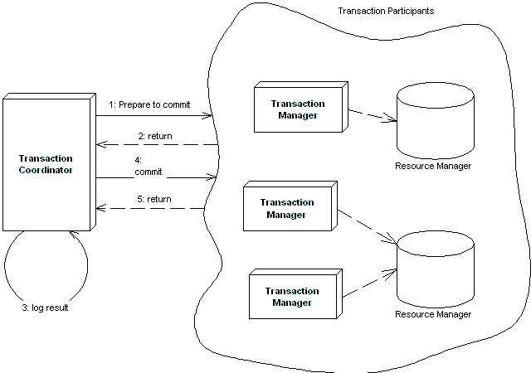
Figure X.X A distributed flat transaction using a two-phase commit protocol.
The Transactional Communications Protocol and
Transaction Contexts
A distributed two-phase commit transaction complicates matters because the transaction managers must all agree on a standard mechanism of communicating. Remember that each of the participants in a distributed transaction may have been written by a different vendor, such as a deployment with heterogeneous application servers. The communication mechanism used is called the transactional communications protocol. An example of such a protocol is the Internet Inter-ORB Protocol (IIOP), which we describe in Chapter X.
The most important piece of information sent over the transactional communications protocol is the transaction context. A transaction context is an object that holds information about the system’s current transactional state. It is passed around between parties involved in transactions. By querying the transaction context, you can gain insight into whether you’re in a transaction, what stage of a transaction you are at, and other useful data. In order for any component to be involved in a transaction, the current thread in which the component is executing must have a transaction context associated with it.
Note
The EJB specification suggests, but does not require, that application server vendors support on-the-wire transaction context interoperability. If an application server does support interoperable transactions, EJB requires that it leverage the transaction context propagation facilities built in to CORBA’s Object Transaction Service (OTS) and the Internet Inter-ORB Protocol (IIOP). Application servers that use these technologies should be interoperable and run in a distributed 2PC transaction.
Since the EJB specification does not require this level of interoperability, application servers from different vendors cannot be guaranteed to work together and participate in a distributed two-phase commit transaction because they will may not be able to communicate in a standard way.
For most users, this is acceptable because distributed 2PC has very poor performance. And more to the point--most organizations are struggling enough as it is with a single application server vendor.
It’s important to understand which communications protocol your application server uses. If you want to perform a distributed two-phase commit transaction, the transaction participants must agree on a standard protocol.
Designing Transactional Conversations in EJB
In this chapter we’ve seen that a transactional abort entails an automatic rollback of database updates that were performed during the transaction. But database updates are only half of the picture. Your application code needs to consider the impacts of a failed transaction as well.
When a transaction aborts, your application code has several choices. You can abort your business process and throw an exception back to the client, or you can attempt to retry the transaction several times. But unfortunately, your application cannot sit in a loop retrying transactions forever, as that would yield horrible performance for concurrent threads of execution. If the transaction cannot eventually be made to succeed, you should consider aborting your business process.
For a stateless session bean, aborting a business process is a simple task--simply throw an exception back to the client. But for a stateful session bean, things are a bit trickier. Stateful session beans represent business processes that span multiple method calls and hence have in-memory conversational state. Tossing away that conversation and throwing an exception to the client could entail a significant amount of lost work.
Fortunately, a well-designed stateful session bean can salvage its conversations in the case of failed transactions. The key is to design your beans to be aware of changes to conversational state and to be smart enough to undo any of those changes in case of a transactional abort.
Because this process is highly application-specific, your application server cannot automate this task for you. Your application server can aid you in determining when a transaction failed, enabling you to take application-specific steps. If your session bean needs to be alerted to transaction status (such as failed transactions), your enterprise bean class can implement an optional interface called javax.ejb.SessionSynchronization, shown in the following code:
public interface javax.ejb.SessionSynchronization
{
public void afterBegin();
public void beforeCompletion();
public void afterCompletion(boolean);
}

You should implement this interface in your enterprise bean class and define your own implementations of each of these methods. The container will call your methods automatically at the appropriate times during transactions, alerting you to important transactional events. This adds to the existing arsenal of alerts that your session beans receive already--life-cycle alerts via ejbCreate() and ejbRemove(), passivation alerts via ejbActivate() and ejbPassivate(), and now transactional alerts via afterBegin(), beforeCompletion(), and afterCompletion().
Here’s what each of the SessionSynchronization methods do:
afterBegin() is called by the container directly after a transaction begins.
beforeCompletion() is called by the container right before a transaction completes.
afterCompletion() is called by the container directly after a transaction completes.
The key method that is most important for rolling back conversations is afterCompletion(). The container calls your afterCompletion() method when a transaction completes either in a commit or an abort. You can figure out whether a commit or an abort happened by the Boolean parameter that gets passed to you in afterCompletion()--true indicates a successful commit, false indicates an abort. If an abort happened, you should roll back your conversational state to preserve your session bean’s conversation.
Here’s an example of afterCompletion() in action:
public class CountBean implements SessionBean, SessionSynchronization {

public int val;
public int oldVal;

public void ejbCreate(int val) {
this.val=val;
this.oldVal=val;
}

public void afterBegin() { oldVal = val;}
public void beforeCompletion() {}
public void afterCompletion(boolean b) { if (b == false) val = oldVal; }

public int count() { return ++val; }
public void ejbRemove() {}
public void ejbActivate() {}
public void ejbPassivate() {}
public void setSessionContext(SessionContext ctx) {}
}

This is a new version of our Count bean from Chapter X. The conversational state is val, an integer that gets incremented whenever count() is called. We also keep a backup copy of val, called oldVal, which we will revert back to in case of transactional rollback. Here is what's going on:
- When our bean is first initialized in ejbCreate(), or when a transaction first begins in afterBegin(), val and oldVal are set to the same value.
- One or more count() business methods are called, incrementing val.
- If the transaction fails, then in the afterCompletion() method is called when the transaction completes. If the transaction failed (that is, if a false value was passed into afterCompletion()) then we rollback our conversational state by reverting back to oldVal.
Note that for the above to work, we must make count() transactional in the deployment descriptor using transaction attributes that we described earlier in this chapter.
SessionSynchronization is also useful when your stateful session bean caches database data in memory during a transaction. You can use SessionSynchronization to track when to cache and when not to cache data as follows:
When the container calls afterBegin(), the transaction has just started. Thus, you should read in any database data you want to cache in your stateful session bean.
When the container calls beforeCompletion(), the transaction has ended. Write out any database data you’ve cached.
Tip
You can implement SessionSynchronization only if you’re using a stateful session bean with declarative (container-managed) transactions. If your bean is using programmatic (bean-managed) transactions, you are already in control of the transaction because you issue the begin(), commit(), and abort() statements. Stateless session beans do not hold conversations and hence do not need these callbacks.
Summary
Whew! That’s a lot of data to digest. You may want to come back and reread this chapter later to make sure you’ve grasped all the concepts.
In this chapter, we learned about transactions and how they can make a server-side deployment robust. We saw the virtues of transactions, which are called the ACID properties. We then looked at different transactional models, including flat and nested transactions.
We then applied this transactional knowledge to EJB. We saw how declarative, programmatic, and client-initiated transactions are useful in EJB, and learned how to code with each model. We then looked at transaction isolation levels and understood the problems that each level solves. Finally, we learned about distributed transactions and the two-phase commit protocol, and ended with a look at writing transactional conversations.
Your efforts reading this chapter were well worth it because now you have a solid foundation in the importance and usefulness of transactions in EJB. You should definitely return to this chapter frequently when you’re creating transactional beans or when you’re just wondering about transactions in general.

